
SIMATS ENGINEERING
Saveetha Institute of Medical and Technical Sciences
Chennai-602105

AQUAGUARD 360: INTELLIGENT WATER QUALITY MONITORING AND PREDICTIVE CONTAMINATION ALERT SYSTEM

S ROOPAN RAJ(192525474)
B.Tech AI&ML

DECLARATION

I hereby declare that the project entitled "AquaGuard 360: Intelligent Water Quality Monitoring and Predictive Contamination Alert System" submitted in partial fulfillment of the requirements for the award of the degree of Bachelor of Engineering in Artificial Intelligence and Machine Learning is a record of original work carried out by me under the guidance of Dr. ANITADAVAMANI, Department of Artificial Intelligence and Machine Learning, Saveetha Engineering College.
I further declare that this project has not previously formed the basis for the award of any degree, diploma, associate ship, fellowship, or any other similar title in any University or Institution.

Date: 5/08/2026 Signature of the Student
Place: Chennai S. ROOPAN RAJ

ACKNOWLEDGEMENT
I express my sincere gratitude to Saveetha Engineering College, Chennai, for providing an excellent academic environment and the necessary facilities to carry out this project successfully.
I extend my heartfelt thanks to the Principal of Saveetha Engineering College for providing continuous encouragement, motivation, and institutional support throughout the completion of this project.
I express my sincere gratitude to the Head of the Department of Artificial Intelligence and Machine Learning for providing valuable guidance, encouragement, and the necessary infrastructure required for the successful completion of this work.
I am deeply indebted to my project guide, Dr. ANITADAVAMANI, for their constant encouragement, technical expertise, valuable suggestions, and continuous supervision throughout every stage of this project. Their guidance played a vital role in shaping this work into its present form.
I also thank all the faculty members of the Department of Artificial Intelligence and Machine Learning for sharing their knowledge and extending their support whenever required.
Finally, I express my heartfelt gratitude to my parents, family members, friends, and classmates for their unwavering encouragement, motivation, and moral support throughout the development of this project.

1. ABSTRACT
Water quality plays an important role in public health, environmental protection, agriculture and industrial development. However, water resources are increasingly affected by industrial discharge, agricultural runoff, microbial contamination and environmental changes. Conventional water quality monitoring generally depends on periodic collection of water samples followed by laboratory testing. Although laboratory analysis is useful for accurately identifying water conditions, the time required for sample collection, transportation, testing and reporting can delay the detection of contamination. In addition, periodic sampling may fail to identify sudden changes occurring between two monitoring intervals.
AquaGuard 360 is proposed as an intelligent water quality monitoring and predictive contamination alert system that integrates Internet of Things (IoT) sensors, cloud computing, artificial intelligence and machine learning. IoT sensors installed at different monitoring locations continuously collect important water quality parameters such as pH, turbidity, temperature, dissolved oxygen, conductivity and supported contaminant measurements. The collected information is transmitted to a centralized cloud platform where it is validated, stored and analyzed.
The proposed system goes beyond conventional real-time monitoring by applying AI and machine-learning techniques to current and historical sensor data. This enables AquaGuard 360 to identify abnormal patterns, analyze water quality trends and predict potential contamination risks. When abnormal conditions or significant risks are detected, the platform generates alerts so that responsible stakeholders can investigate the affected water source and take appropriate action.
AquaGuard 360 also provides interactive dashboards for viewing live sensor readings, historical trends, predictions and alerts across multiple monitoring locations. Automated reporting supports environmental analysis and regulatory activities. By integrating continuous sensing, centralized monitoring and predictive analytics, AquaGuard 360 aims to improve early contamination detection, reduce monitoring delays and support better water resource management.

2. INTRODUCTION
Access to clean and safe water is essential for human life and sustainable development. Water is required not only for drinking but also for sanitation, agriculture, food production, manufacturing and several industrial processes. The quality of available water therefore has a direct effect on public health, environmental sustainability and economic activities. Increasing population, urban development, industrialization and changing environmental conditions have created greater pressure on available water resources and have increased the importance of effective water quality monitoring.
Water sources can become contaminated through several mechanisms. Industrial discharge may introduce pollutants into rivers and other nearby water bodies, while agricultural runoff may carry fertilizers and other unwanted substances. Improper waste disposal and microbial contamination can also affect water safety. Climate-related environmental changes may influence water temperature, dissolved oxygen and other characteristics. Since contamination may occur unexpectedly, authorities need reliable information about changes in water quality.
Several parameters can be used to understand the condition of a water source. The AquaGuard 360 scenario focuses on parameters including pH, turbidity, temperature, dissolved oxygen, conductivity and contaminants. Continuous observation of these parameters provides useful information regarding changes occurring within the monitored water source.
Conventional monitoring methods generally involve collecting water samples from selected locations and transporting them to laboratories for analysis. Laboratory testing remains important, particularly where detailed analysis or confirmation of specific contaminants is necessary. However, this approach has limitations when continuous observation is required. A laboratory result represents the condition of a sample collected at a particular point in time. If contamination occurs after the sample is collected, the change may remain undetected until another sample is taken.
The development of IoT sensors and wireless communication provides an opportunity to overcome this monitoring gap. Sensors can remain installed at monitoring locations and collect measurements at regular intervals. The measurements can then be transmitted automatically to a centralized platform without requiring personnel to physically collect every reading.
Cloud computing further improves this approach by providing centralized storage and processing capabilities. Information generated by sensors located at several water sources can be maintained within a common environment. Authorized personnel can therefore supervise multiple monitoring locations through a single system rather than relying on separate records for each location.
Artificial intelligence and machine learning provide another important capability. Instead of simply displaying sensor measurements, an intelligent monitoring system can analyze historical and current information to identify unusual patterns. This creates the possibility of predicting deteriorating water conditions before they become more serious.
AquaGuard 360 is designed around this concept. It combines IoT-based data acquisition, cloud-based centralized storage, AI-driven predictive analysis, real-time visualization, automated alerts and reporting within a single water quality monitoring platform. The purpose is to support a transition from periodic and mainly reactive monitoring toward continuous and predictive water quality management.

3. PROBLEM STATEMENT AND EXISTING CHALLENGES
The major problem addressed by AquaGuard 360 is the inability of conventional monitoring systems to provide immediate and continuous detection of changing water quality conditions. Manual sample collection and laboratory analysis involve several stages before the final result becomes available. During this period, contaminated water may remain within the source or distribution environment before responsible authorities become aware of the problem.
Another significant challenge is the periodic nature of conventional monitoring. Suppose a water source is tested and the collected sample indicates acceptable conditions. If contamination occurs several hours after the sample has been collected, authorities may have no immediate indication of the change. The next scheduled monitoring activity may occur only after the water quality has already deteriorated. Therefore, periodic observations cannot always provide a complete representation of continuously changing environmental conditions.
Manual monitoring also becomes increasingly difficult when an organization is responsible for several water sources. Personnel may need to visit multiple locations, collect samples, maintain records and coordinate laboratory analysis. Information from different locations may also be maintained separately, making centralized supervision and comparison more difficult.
A further limitation is the lack of predictive analysis. Traditional monitoring primarily determines the condition of water that has already been sampled. Although this information is valuable, it provides limited support for predicting what may happen next. Historical measurements can contain patterns showing gradual changes in water conditions. Without suitable analytical tools, these patterns may not be identified early enough to support preventive action.
The communication of abnormal results creates another challenge. Even after a problem has been detected, the information must reach the personnel responsible for taking action. A delay between detection and communication may further increase response time. Therefore, an effective monitoring platform should not only identify abnormalities but should also generate immediate and understandable alerts.
The AquaGuard 360 problem statement therefore establishes the need for a centralized intelligent platform capable of continuous sensor monitoring, anomaly detection, contamination prediction, real-time alert generation, historical analysis and automated reporting. These capabilities address the major limitations identified in the existing monitoring approach.

4. PROPOSED SYSTEM
AquaGuard 360 is proposed as an IoT-enabled intelligent monitoring platform capable of collecting and analyzing water quality information from multiple monitoring locations. The proposed system begins with sensors installed at water sources. These sensors continuously or periodically measure the required water quality parameters and transmit the readings through the available communication infrastructure.
Once sensor information reaches the AquaGuard 360 platform, the measurements are validated and associated with the correct sensor and monitoring location. Valid readings are stored in centralized cloud-based storage. This creates a historical record of water conditions and allows authorized users to access information from multiple locations through a common interface.
The monitoring dashboard presents the latest sensor readings in a clear visual format. Instead of manually reviewing large quantities of numerical data, users can observe parameter values and historical trends through graphs and indicators. This makes it easier to identify unusual changes in monitored water sources.
The AI/ML component analyzes current and historical information to identify abnormal behaviour and estimate contamination risk. If the analytical process detects a significant abnormality or predicts possible deterioration, AquaGuard 360 generates an alert. Relevant stakeholders can then examine the affected location, inspect recent measurements and determine whether further investigation or corrective action is required.
The overall operation of the system can therefore be represented as:
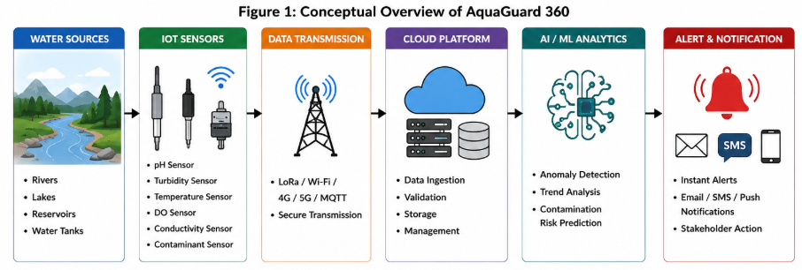
AquaGuard 360 is not intended to completely replace laboratory analysis. Detailed laboratory testing may still be necessary to confirm contamination or identify substances that cannot be directly measured using the installed sensors. Instead, the proposed system provides continuous surveillance and early-warning capabilities that complement existing testing procedures.
The difference between conventional monitoring and AquaGuard 360 can be summarized as follows.
Aspect | Conventional Monitoring | AquaGuard 360
Data Collection | Periodic manual sampling | Continuous IoT sensing
Detection | After sample analysis | Near-real-time detection
Data Storage | May be distributed | Centralized cloud storage
Monitoring | Individual locations | Multiple locations centrally
Prediction | Limited | AI/ML-based prediction
Alerts | Mostly manual | Automated alerts
Historical Analysis | Manual comparison | Integrated trend analysis
Reporting | Manual preparation | Automated reporting support
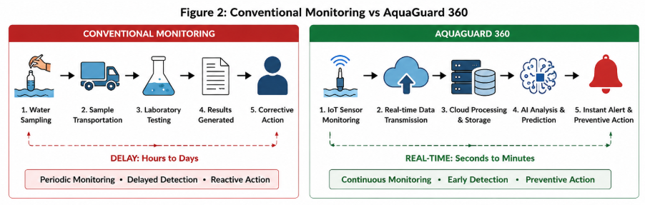The comparison demonstrates that the proposed system does not simply automate the existing process. It introduces continuous data acquisition, centralized supervision and predictive analytics. This allows water authorities to move from responding only after contamination has been confirmed toward identifying potential risks at an earlier stage.

5. OBJECTIVES AND SCOPE
The main objective of AquaGuard 360 is to develop an intelligent platform capable of continuously monitoring water quality using IoT sensors. The system should monitor important parameters including pH, turbidity, temperature, dissolved oxygen, conductivity and supported contaminants across multiple water sources. The measurements should be stored centrally so that both current and historical information can be accessed through the platform.
Another important objective is to apply artificial intelligence and machine learning to water quality information. The system should analyze historical and recent measurements to identify abnormalities, study trends and estimate potential contamination risks. When abnormal conditions are detected, AquaGuard 360 should generate timely alerts so that responsible stakeholders can investigate the situation.
The platform should also provide interactive visualization. Authorized users should be able to view current sensor readings, historical trends, alerts and predictive information through a centralized dashboard. Reporting functionality should support monitoring activities, historical analysis and regulatory documentation.
The scope of AquaGuard 360 includes user management, water-source management, IoT sensor integration, real-time data collection, data validation, centralized storage, AI/ML analysis, anomaly detection, contamination prediction, dashboard visualization, alert management, historical analysis and report generation. The architecture should also support the future addition of new sensors and monitoring locations.
The system boundary does not include physical purification of contaminated water, automatic chemical treatment or physical repair of water infrastructure. AquaGuard 360 provides monitoring and decision-support information, while the final physical response remains the responsibility of the appropriate authorities. Similarly, laboratory testing remains outside the direct system boundary and may be used to confirm significant contamination events.

6. STAKEHOLDER ANALYSIS
AquaGuard 360 serves several stakeholders whose requirements must be considered during software development. The Water Utility Operator is one of the primary operational users. This stakeholder requires access to live water quality measurements, historical trends, active alerts and contamination predictions. When an abnormal condition is identified, the operator should be able to review the affected monitoring location and acknowledge the corresponding alert.
The Environmental Officer requires historical and analytical information for studying environmental changes. This stakeholder may examine long-term trends, compare different monitoring locations and review contamination events. The Regulatory Authority similarly requires access to appropriate monitoring records and reports for compliance and environmental assessment purposes.
The System Administrator manages the AquaGuard 360 software environment. Administrative responsibilities include managing users and roles, registering sensors, maintaining monitoring locations and configuring relevant system settings. Because these capabilities can significantly affect the monitoring platform, they should be restricted to authorized administrative users.
The Field Technician is primarily concerned with physical sensor infrastructure. Sensor-status information can help identify devices that have stopped communicating or may require maintenance. The IoT Sensor Network itself acts as an external technical actor because it supplies the measurements required by AquaGuard 360. A Notification Service also acts as an external component responsible for delivering important alerts through supported communication mechanisms.
Stakeholder | Primary Need
Water Utility Operator | Live monitoring, alerts and predictions
Environmental Officer | Historical trends and environmental analysis
System Administrator | User, sensor and system management
Field Technician | Sensor status and maintenance information
Regulatory Authority | Monitoring records and reports
IoT Sensor Network | Transfer sensor measurements
Notification Service | Deliver alert information
These stakeholder requirements provide the foundation for the formal functional and non-functional requirements specified in the next part of the report. The stakeholder analysis also demonstrates the need for role-based access control because different users require different levels of system functionality.

7. FUNCTIONAL REQUIREMENTS
Functional requirements define the major services provided by AquaGuard 360. Instead of treating every individual function as a separate section, the requirements are grouped according to the major modules of the proposed platform.
User and Access Management
AquaGuard 360 should provide secure authentication for registered users. After successful login, access to system functionality should be controlled according to the user's assigned role. For example, Water Utility Operators require monitoring and alert information, while System Administrators require additional permissions for managing users, sensors and system configuration. Role-based access prevents unauthorized users from changing critical monitoring settings.
Water Source and IoT Sensor Management
The platform should allow authorized administrators to register and manage multiple water sources and monitoring locations. Each monitoring location should be associated with the appropriate IoT sensors so that incoming measurements can be correctly identified.
Sensor information should include a unique sensor identifier, parameter type, monitoring location and operational status. AquaGuard 360 should also identify sensors that stop transmitting information so that a communication or hardware failure is not incorrectly interpreted as normal water conditions.
Real-Time Water Quality Monitoring
AquaGuard 360 should continuously receive measurements from registered IoT sensors. The primary parameters specified for the system include pH, turbidity, temperature, dissolved oxygen, conductivity and supported contaminant measurements.
Every sensor reading should contain information identifying the sensor, measured parameter, value and timestamp. The system should support simultaneous monitoring of multiple water sources and ensure that readings remain associated with the correct location.
Incoming sensor information should be validated before being used for monitoring and prediction. Incomplete or clearly invalid measurements should be identified so that inaccurate information does not unnecessarily influence analytical results.
Centralized Data Storage and Historical Analysis
Validated measurements should be stored in a centralized database. Maintaining historical records allows AquaGuard 360 to provide long-term trend analysis and also supplies the information required by the AI/ML component.
Authorized users should be able to retrieve previous measurements by selecting a water source, monitoring location, parameter and time period. Historical information should be displayed through appropriate graphs or charts so that gradual changes can be identified more easily.
Dashboard and Visualization
AquaGuard 360 should provide an interactive dashboard through which authorized users can monitor current water conditions. The dashboard should display the latest available sensor readings together with information identifying the corresponding water source and monitoring location.
Users should be able to switch between different monitoring locations and parameters. Current readings, historical trends, active alerts and relevant predictive information should be presented clearly without requiring users to manually interpret large quantities of raw data.
AI-Based Anomaly Detection and Contamination Prediction
Artificial intelligence and machine learning form an important part of AquaGuard 360. The analytical component should process validated current and historical measurements to identify unusual patterns in water quality.
The system should support anomaly detection to identify conditions that differ significantly from expected behaviour. It should also generate contamination-risk predictions using available historical and recent sensor information. Prediction results should remain clearly distinguishable from actual sensor measurements because predictions represent analytical estimates rather than direct physical observations.
If the system identifies a significant abnormality or elevated contamination risk, the result should be transferred to the alert-management component for further action.
Alert and Notification Management
AquaGuard 360 should automatically generate an alert when an abnormal water quality condition or significant predicted contamination risk is identified. The alert should contain relevant information such as the affected monitoring location, detected condition, severity and timestamp.
Alerts should be visible to authorized users through the dashboard and should also be provided to the configured notification mechanism. Depending on implementation, notifications may be delivered through supported channels such as email, SMS or application notifications.
Authorized operators should be able to acknowledge alerts after reviewing them. AquaGuard 360 should maintain historical alert records so that previous contamination events and recurring abnormalities can later be analyzed.
Reporting and Administration
The platform should allow authorized stakeholders to generate reports using stored monitoring information. Reports may contain selected water quality measurements, historical trends, predictions and alert records for a specified location and time period. This functionality supports operational analysis and regulatory documentation.
System administrators should also be able to maintain users, roles, sensors, water sources and relevant monitoring configurations. Important administrative activities should be recorded where necessary to provide traceability.
The main functional requirements are summarized below.
ID | Functional Requirement
FR-01 | Authenticate registered users
FR-02 | Provide role-based access control
FR-03 | Manage users and stakeholder roles
FR-04 | Register and manage water sources and monitoring locations
FR-05 | Register and manage IoT sensors
FR-06 | Monitor sensor operational status
FR-07 | Collect real-time water quality measurements
FR-08 | Monitor pH, turbidity, temperature, dissolved oxygen, conductivity and contaminants
FR-09 | Validate incoming sensor measurements
FR-10 | Store validated measurements centrally
FR-11 | Retrieve and analyze historical measurements
FR-12 | Display live water quality through an interactive dashboard
FR-13 | Visualize historical trends
FR-14 | Detect abnormal water quality conditions
FR-15 | Apply AI/ML for contamination-risk prediction
FR-16 | Display predictive analysis results
FR-17 | Automatically generate contamination alerts
FR-18 | Classify and communicate alerts
FR-19 | Allow authorized users to acknowledge alerts
FR-20 | Maintain alert history
FR-21 | Generate water quality and compliance reports
FR-22 | Support centralized monitoring of multiple locations
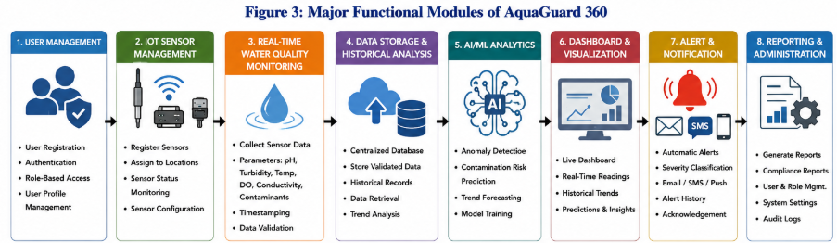

8. NON-FUNCTIONAL REQUIREMENTS

Non-functional requirements describe the expected quality of AquaGuard 360 rather than individual system operations. Since the platform is intended for continuous environmental monitoring, qualities such as performance, reliability, security and scalability are important.
Performance and Availability
AquaGuard 360 should process incoming sensor measurements with sufficiently low delay to support near-real-time monitoring. Current information should become available through the dashboard without unnecessary processing delays, while abnormal conditions should be given priority during alert processing.
The system should be designed for continuous operation because water quality can change at any time. Failure of an individual sensor should not cause failure of the entire monitoring platform. If a sensor becomes unavailable, the system should identify the missing information while allowing other monitoring locations to continue operating.
Security and Privacy
Only authenticated users should be allowed to access protected system functions. Authorization should be based on user roles so that users can perform only activities appropriate to their responsibilities.
Communication between important system components should use appropriate security mechanisms, and stored information should be protected from unauthorized modification. Administrative actions should also be traceable where necessary.
Reliability and Data Integrity
Sensor measurements must remain correctly associated with the originating sensor, monitoring location, parameter and timestamp. Invalid or incomplete information should not be silently treated as reliable monitoring data.
Historical information should be protected against unauthorized modification. Appropriate backup and recovery mechanisms should also be available so that critical monitoring records are not permanently lost because of storage or system failure.
Scalability and Maintainability
The platform should support the addition of new sensors, users and monitoring locations as the deployment expands. The storage architecture should also accommodate increasing quantities of historical sensor information.
A modular software design should be used so that components such as IoT communication, AI/ML analysis, dashboard visualization and reporting can be maintained independently where practical. The architecture should also support future integration of additional sensor types and analytical models.
Usability
AquaGuard 360 should provide a clear and understandable user interface. Water Utility Operators and other monitoring personnel should be able to identify current conditions and important alerts without requiring extensive technical knowledge of the underlying AI or IoT infrastructure.
Navigation should remain consistent across major modules. Important alerts should be visually distinguishable from ordinary monitoring information, while graphs and historical visualizations should use understandable labels and units.
The major non-functional requirements are summarized below.
ID | Category | Requirement
NFR-01 | Performance | Process sensor information with low monitoring delay
NFR-02 | Performance | Provide responsive dashboard access
NFR-03 | Availability | Support continuous monitoring operation
NFR-04 | Reliability | Isolate individual sensor failures where possible
NFR-05 | Security | Require authenticated access
NFR-06 | Security | Apply role-based authorization
NFR-07 | Security | Protect transmitted and stored information
NFR-08 | Integrity | Maintain correct sensor/location/data relationships
NFR-09 | Recovery | Support backup and recovery of monitoring data
NFR-10 | Scalability | Support additional sensors and monitoring locations
NFR-11 | Maintainability | Use a modular system architecture
NFR-12 | Extensibility | Support additional parameters and analytical models
NFR-13 | Usability | Provide a clear and consistent dashboard
NFR-14 | Interoperability | Support defined interfaces for sensors, AI and notifications

9. REQUIREMENT PRIORITIZATION

The requirements of AquaGuard 360 can be prioritized using the MoSCoW technique, which divides requirements into Must Have, Should Have, Could Have and Won't Have categories. Prioritization is useful because the essential monitoring and safety-related capabilities should be implemented before optional enhancements.
Must Have requirements include secure authentication, sensor registration, real-time data collection, centralized storage, live monitoring, anomaly detection, AI-based contamination prediction and alert generation. Without these functions, AquaGuard 360 would not satisfy its primary purpose.
Should Have requirements include advanced historical visualization, sensor-status monitoring, alert acknowledgement and detailed automated reporting. These provide significant operational value but can be developed after the fundamental monitoring pipeline is established.
Could Have requirements include features such as geographic map visualization, advanced dashboard customization, additional notification channels and expanded AI explanations. These features can improve the platform but are not essential for the initial implementation.
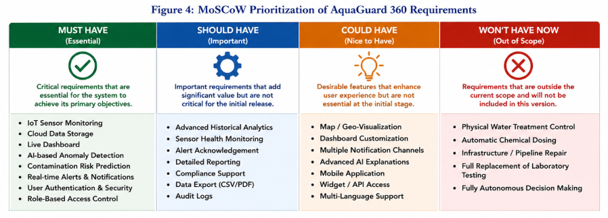
10. ACTORS AND USE CASES
An actor represents a user, device or external service that interacts with AquaGuard 360. Based on the stakeholder analysis, the major actors are the Water Utility Operator, Environmental Officer, System Administrator, Field Technician, Regulatory Authority, IoT Sensor Network and Notification Service.
The Water Utility Operator is responsible for monitoring live water quality, reviewing alerts and observing predictive results. Environmental Officers primarily use historical measurements and analytical information to study changes in water quality. System Administrators maintain users, sensors, monitoring locations and system settings, while Field Technicians use sensor-status information to identify devices requiring maintenance. Regulatory Authorities access historical records and reports for monitoring and compliance purposes.
The IoT Sensor Network acts as an external technical actor that continuously provides water quality measurements to the system. The Notification Service is responsible for delivering generated alerts to relevant stakeholders through the supported communication mechanism.
The relationship between the actors and the major AquaGuard 360 functions is summarized below.
Actor | Major Interactions
Water Utility Operator | View dashboard, monitor water quality, review predictions, receive and acknowledge alerts
Environmental Officer | Analyze historical trends, review contamination information, generate reports
System Administrator | Manage users, sensors, locations and configuration
Field Technician | View sensor status and maintenance information
Regulatory Authority | Access historical records and compliance reports
IoT Sensor Network | Transmit water quality measurements
Notification Service | Deliver generated alerts
The principal use cases of AquaGuard 360 include Authenticate User, Monitor Water Quality, Manage Sensors, View Historical Trends, Detect Anomaly, Predict Contamination Risk, Generate Alert, Acknowledge Alert, Generate Report and Manage System Configuration.
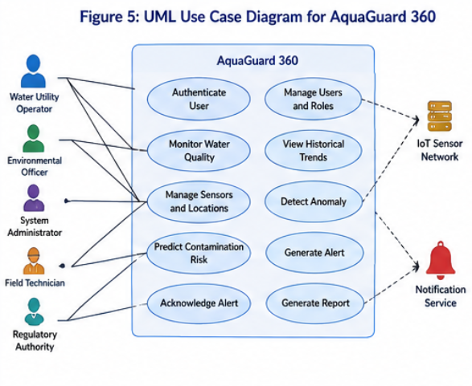

11. USE CASE SPECIFICATION
A Use Case Specification provides more detail about the interaction represented in the UML diagram. It identifies the actor, objective, precondition, main sequence and expected result of an important system operation.
The major AquaGuard 360 use cases are described below.
Use Case | Primary Actor | Description | Precondition | Expected Result
UC-01 Authenticate User | Registered User | User submits credentials to access AquaGuard 360 | Active user account exists | User receives access according to assigned role
UC-02 Collect Sensor Data | IoT Sensor Network | Sensor sends water quality measurements | Sensor is registered | Valid measurements are stored
UC-03 Monitor Water Quality | Water Utility Operator | User views current measurements for selected location | User is authenticated and data is available | Current water conditions are displayed
UC-04 View Historical Trends | Operator / Environmental Officer | User requests previous measurements for a selected period | Historical data exists | Trend information is displayed
UC-05 Detect Anomaly | AquaGuard Analytics | Monitoring information is analyzed for abnormal behaviour | Valid sensor data is available | Abnormal conditions are identified
UC-06 Predict Contamination | AI/ML Component | Historical and recent measurements are analyzed | Sufficient data is available | Contamination-risk prediction is generated
UC-07 Generate Alert | AquaGuard 360 | System creates alert for significant abnormality or predicted risk | Alert condition is satisfied | Alert is recorded and communicated
UC-08 Generate Report | Authorized User | User selects location, parameter and period | User has reporting permission | Water quality report is produced
For example, during the Monitor Water Quality use case, the Water Utility Operator first authenticates with the system and opens the monitoring dashboard. The operator selects a water source or monitoring location, after which AquaGuard 360 retrieves the most recent sensor readings. The readings are displayed through appropriate indicators or graphs. If recent data is unavailable, the system should clearly indicate the missing information instead of presenting old measurements as current information.
During the Predict Contamination Risk use case, validated current and historical measurements are prepared for the AI/ML model. The analytical component examines patterns within the selected parameters and produces a prediction result. The result is stored with the corresponding monitoring location and timestamp. If the predicted risk exceeds the configured alert condition, the alert-management process is activated.
The Generate Alert use case begins when either an abnormal sensor condition or a significant predictive risk is identified. AquaGuard 360 creates an alert containing the affected location, event information, severity and timestamp. The alert becomes visible through the dashboard and is passed to the Notification Service. An authorized operator can subsequently acknowledge the alert after reviewing the condition.
These use cases establish a clear relationship between the stakeholder requirements identified earlier and the expected behaviour of the proposed system.
12. SYSTEM ARCHITECTURE AND DATA FLOW
AquaGuard 360 follows a layered architecture in which data moves from the physical monitoring environment to the user-facing application. Separating the platform into logical components improves maintainability and allows individual areas of the system to evolve without requiring complete redesign.
The first component is the IoT Sensor Layer. Sensors installed at water sources collect measurements such as pH, turbidity, temperature, dissolved oxygen and conductivity. Each sensor is associated with a registered monitoring location so that the origin of every measurement can be identified.
The Communication Layer transfers sensor information to the centralized environment. Depending on the deployment, technologies such as Wi-Fi, cellular communication or other suitable IoT communication methods can be used. The requirement at the software level is that measurements reach the platform in a consistent and identifiable format.
The Cloud Processing and Storage Layer receives the measurements, validates them and stores accepted information in the centralized database. Historical storage allows previous water conditions to be retrieved and provides data for analytical processing.
The AI/ML Analytics Layer uses current and historical information for anomaly detection, trend analysis and contamination-risk prediction. Analytical results are returned to the application layer, where they can be displayed or used to trigger alerts.
The Application Layer contains the dashboard, historical analysis, alert management, reporting and administrative functions used by authorized stakeholders. Finally, the Notification Component delivers significant alerts
the relevant personnel

.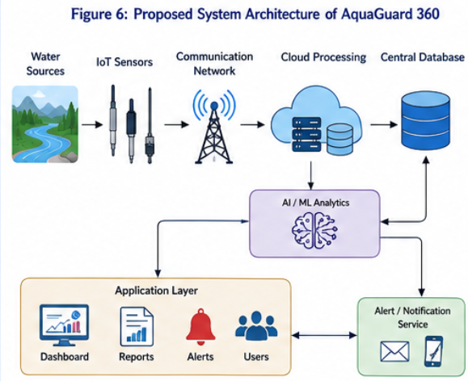
In the Level 0 Data Flow Diagram, the IoT Sensor Network provides sensor measurements to AquaGuard 360. Administrators provide configuration and management information, while operational users submit monitoring or reporting requests. AquaGuard 360 processes these requests using information maintained in the centralized database and returns dashboards, predictions, alerts or reports. Alert information is also provided to the external Notification Service.
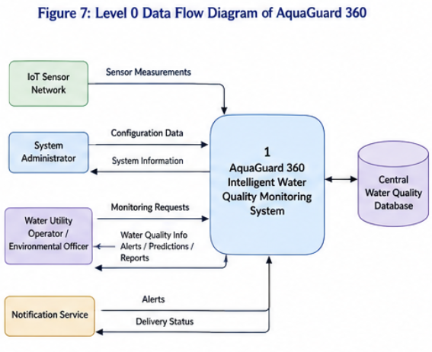

13. DATA REQUIREMENTS AND ENTITY RELATIONSHIPS
AquaGuard 360 requires structured data to support monitoring, analytics and reporting. The major data entities are User, Role, Water Source, Monitoring Location, Sensor, Sensor Reading, Prediction, Alert, Report and Audit Log.
User information is required for authentication and authorization. Each user is associated with a role that determines the functions available to that account. Water Source records identify the physical water resources being monitored, while Monitoring Location records identify the individual points at which sensors are installed.
Each Sensor record contains information such as Sensor ID, parameter type, monitoring location and operational status. A sensor can generate a large number of Sensor Reading records over time. Every reading should contain the measured value and timestamp and remain associated with the correct sensor.
Prediction records store analytical results generated by the AI/ML component. These should remain separate from Sensor Reading records because a prediction represents a calculated analytical result rather than a directly measured physical value.
Alert records maintain information about abnormal events. Relevant attributes include the affected monitoring location, alert category, severity, generation time and acknowledgement status. Reports contain information about generated monitoring or analytical documents, while Audit Logs record significant administrative activities.
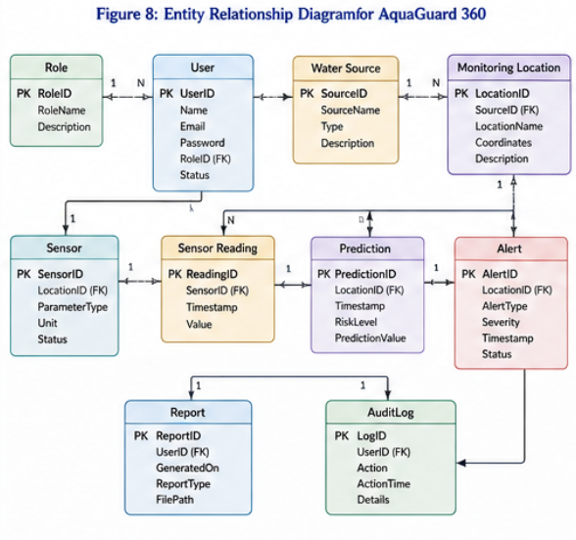

14. EXTERNAL INTERFACE REQUIREMENTS
AquaGuard 360 communicates with both human users and external technical components. The major interfaces are the User Interface, IoT Sensor Interface, AI/ML Interface, Database Interface and Notification Interface.
The User Interface should provide a clear dashboard through which authorized personnel can monitor current water quality, select monitoring locations, view historical trends, inspect predictions and review alerts. Administrative functionality should be separated from normal monitoring functions so that configuration changes are restricted to authorized users.
The IoT Sensor Interface is responsible for receiving measurements from registered devices. Sensor information should follow a consistent structure containing the sensor identifier, measured parameter, value and timestamp. The system should validate incoming information before storing it.
The AI/ML Interface transfers prepared monitoring data to the analytical component and receives anomaly or contamination-risk results. The system should clearly differentiate AI-generated predictions from physical sensor readings.
The Database Interface manages storage and retrieval of users, sensors, monitoring locations, readings, predictions, alerts and reports. Ordinary users should interact with stored information through the AquaGuard 360 application rather than directly modifying database records.
The Notification Interface connects the alert-management component with the supported communication service. Relevant alert information such as severity, location and timestamp can then be delivered to responsible stakeholders.

15. IOT AND AI MONITORING WORKFLOW
The complete AquaGuard 360 workflow begins at the physical water source. Sensors collect measurements from the monitored environment and transmit the information to the centralized cloud platform. The incoming data is validated to ensure that the sensor is registered and that the required measurement information is present.
Accepted measurements are stored in the database and become available through the live monitoring dashboard. At the same time, relevant current and historical measurements are supplied to the AI/ML component for analysis.
The analytical component performs anomaly detection and contamination-risk prediction. If the resulting condition is considered normal, AquaGuard 360 stores the information and continues monitoring. If an abnormal condition or significant predicted risk is identified, the system generates an alert.
The alert is displayed through the dashboard and transferred to the Notification Service. The responsible stakeholder can then investigate the affected monitoring location, review current measurements, examine historical trends and determine the appropriate response.

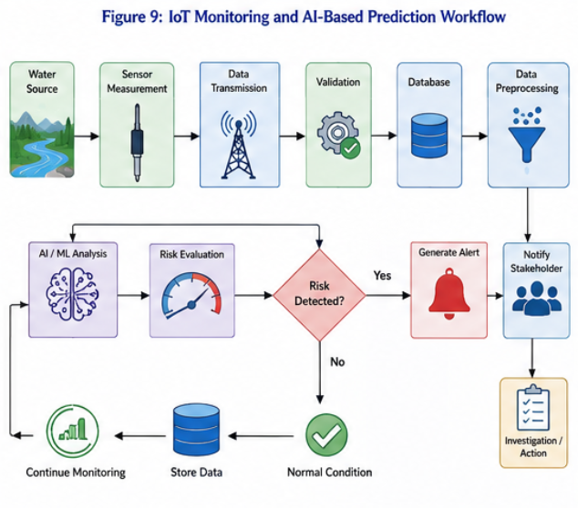
16. JIRA PROJECT AND REQUIREMENT ORGANIZATION
A Jira software project can be created specifically for the proposed system using the project name AquaGuard 360 – Intelligent Water Quality Monitoring System and a suitable project key such as AQG. The project acts as a centralized workspace for maintaining and tracking the software requirements.
The requirements are organized hierarchically as:
AquaGuard 360 Project → Epics → User Stories → Tasks/Subtasks
An Epic represents a major functional area of AquaGuard 360. A User Story represents a specific stakeholder requirement within that area, while Tasks or Subtasks represent the development activities required to implement the story. This structure allows large requirements to be divided into smaller and more manageable units.
The major AquaGuard 360 Epics can be organized as follows:

Epic | Major Requirement Area
EP-01 User & Access Management | Authentication and role-based access
EP-02 IoT Sensor Management | Sensor registration and monitoring
EP-03 Real-Time Water Quality Monitoring | Collection of live water quality data
EP-04 Data Management & Cloud Storage | Validation and historical storage
EP-05 AI Contamination Prediction | Anomaly detection and predictive analysis
EP-06 Alert & Notification Management | Alerts and stakeholder notification
EP-07 Dashboard & Visualization | Live and historical visualization
EP-08 Reporting & Compliance | Reports and regulatory support
These Epics correspond to the functional requirement groups established earlier. For example, EP-03 represents the real-time monitoring requirements, while EP-05 contains requirements related to anomaly detection and contamination-risk prediction.
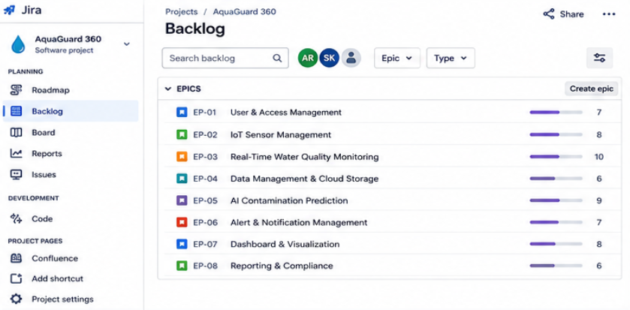
17. USER STORIES AND ACCEPTANCE CRITERIA
The high-level Epics are divided into User Stories. A User Story describes a requirement from the perspective of the stakeholder who needs the functionality. AquaGuard 360 follows the commonly used structure:
As a [user], I want [functionality], so that [benefit].
For example, the requirement for live water quality monitoring can be represented as:
US-03 – Monitor Live Water Quality
As a Water Utility Operator, I want to view live water quality measurements from the selected monitoring location so that I can quickly identify changes in current water conditions.
Similarly, contamination prediction can be represented as:
US-06 – Predict Contamination Risk
As an Environmental Officer, I want AquaGuard 360 to analyze current and historical sensor information and predict contamination risk so that possible deterioration can be investigated at an early stage.
Other important User Stories include:
ID | User Story | Related Requirement
US-01 | Secure User Login | FR-01, FR-02
US-02 | Register IoT Sensor | FR-05
US-03 | Monitor Live Water Quality | FR-07, FR-08, FR-12
US-04 | View Historical Trends | FR-11, FR-13
US-05 | Detect Abnormal Water Conditions | FR-14
US-06 | Predict Contamination Risk | FR-15, FR-16
US-07 | Receive Contamination Alert | FR-17, FR-18
US-08 | Acknowledge Alert | FR-19
US-09 | Generate Water Quality Report | FR-21
US-10 | Monitor Sensor Status | FR-06

Creating User Stories in this manner maintains a direct relationship between the formal SRS requirement and the stakeholder who benefits from the feature.
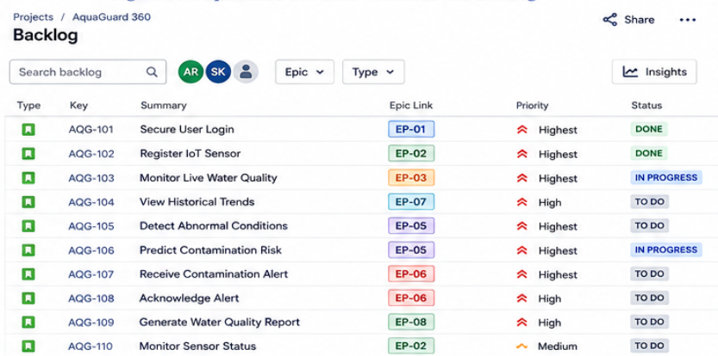

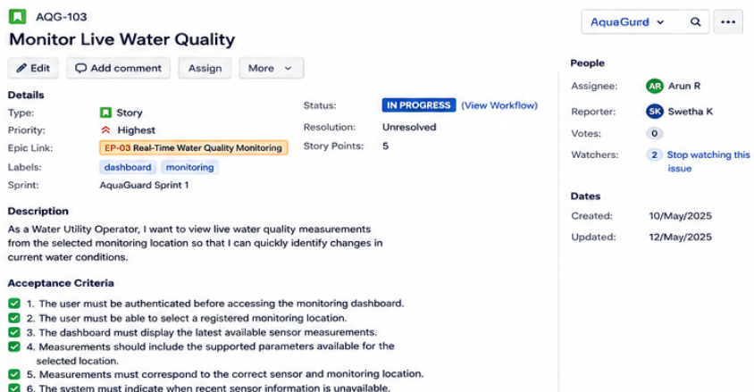

18. REQUIREMENT PRIORITIZATION AND TRACEABILITY
The MoSCoW prioritization developed in Part 2 can be connected with Jira priorities. Requirements classified as Must Have should receive the highest development priority because they are necessary for the fundamental operation of AquaGuard 360.
For example, authentication, IoT data collection, live monitoring, AI contamination prediction and alert generation are Must Have requirements and can therefore be assigned Highest priority. Historical analysis and sensor-health monitoring can be assigned High priority, while optional dashboard customization or future visualization enhancements can receive Medium or Low priority.
Requirement traceability is also maintained by connecting each Jira User Story with its corresponding SRS requirement identifier. This allows the development team to trace a requirement from the original problem statement through implementation and validation.
The traceability process can be represented as:
Problem Statement → System Objective → SRS Requirement → Jira Epic → User Story → Acceptance Criteria → Development Task → Validation
For example, the original AquaGuard 360 problem states that authorities require rapid notification when abnormal water quality conditions occur. This produces the functional requirements FR-17 – Automatically Generate Contamination Alerts and FR-18 – Classify and Communicate Alerts.
These requirements are mapped to EP-06 – Alert & Notification Management and then represented through US-07 – Receive Contamination Alert. Acceptance criteria specify the conditions required for successful implementation.
A compact Requirement Traceability Matrix is shown below.

SRS ID | Jira Epic | User Story | Priority | Validation
FR-01 | EP-01 | Secure User Login | Highest | Authentication Test
FR-05 | EP-02 | Register IoT Sensor | Highest | Sensor Registration Test
FR-12 | EP-03 | Monitor Live Water Quality | Highest | Dashboard Test
FR-13 | EP-07 | View Historical Trends | High | Trend Visualization Test
FR-14 | EP-05 | Detect Abnormal Conditions | Highest | Anomaly Detection Test
FR-15 | EP-05 | Predict Contamination Risk | Highest | Prediction Validation
FR-17 | EP-06 | Receive Contamination Alert | Highest | Alert Trigger Test
FR-19 | EP-06 | Acknowledge Alert | High | Alert Status Test
FR-21 | EP-08 | Generate Water Quality Report | High | Report Generation Test
The matrix ensures that important requirements remain connected with development and testing activities. If a requirement changes, its corresponding Jira item and validation activity can be identified more easily.

19. JIRA WORKFLOW AND REQUIREMENT TRACKING
After the requirements are organized into Epics and User Stories, their implementation progress can be monitored through the Jira board. A simple workflow suitable for AquaGuard 360 is:
TO DO → IN PROGRESS → TESTING/REVIEW → DONE
Requirements that have been analyzed but whose implementation has not started remain in To Do. Once development begins, the User Story moves to In Progress. After implementation, the story moves to Testing/Review, where its acceptance criteria are verified. Only after the required conditions have been satisfied should the story be moved to Done.
For example, the Jira board could show Generate Water Quality Report in To Do, Predict Contamination Risk in In Progress, Monitor Live Water Quality in Testing/Review and Secure User Login in Done. This demonstrates that different requirements can be tracked independently throughout development
20. REQUIREMENT VALIDATION AND PRACTICAL TOOL USAGE
Requirement validation ensures that the documented requirements accurately represent stakeholder needs and can be realistically implemented and tested. AquaGuard 360 requirements should be checked for correctness, completeness, consistency, feasibility, clarity and testability.
Correctness verifies whether a requirement represents an actual stakeholder or system need. Completeness ensures that sufficient information is provided to understand the required functionality. Consistency checks whether one requirement conflicts with another, while feasibility determines whether the requirement can reasonably be implemented using the proposed IoT, cloud and AI architecture.
Clarity is particularly important because ambiguous requirements can lead to different interpretations by developers and stakeholders. Acceptance criteria improve clarity by defining observable conditions for successful implementation. Testability ensures that the development team can later determine whether a requirement has been satisfied.
For example, the requirement “AquaGuard 360 should quickly show water information” is ambiguous because the meaning of "quickly" and the required information are unclear. A better requirement identifies the required dashboard functionality, data source and expected behaviour when information is unavailable.
The combination of the formal SRS and Jira therefore provides a stronger requirement-management process. The SRS contains the complete structured specification, while Jira converts selected requirements into actionable development items and provides tools for prioritization, tracking and validation.
21. ASSUMPTIONS AND CONSTRAINTS
Software requirements are developed based on certain assumptions about the operating environment. Clearly documenting these assumptions prevents them from becoming hidden dependencies during development.
For AquaGuard 360, it is assumed that IoT sensors are installed at appropriate monitoring locations and are capable of measuring the required water quality parameters. The sensors are expected to provide measurements in a format that can be processed by the platform. It is also assumed that a suitable communication network is available for transmitting sensor information to the centralized system.
The system assumes that authorized users such as Water Utility Operators, Environmental Officers and System Administrators have access to suitable devices and network connectivity for using the AquaGuard 360 dashboard. The AI/ML component assumes that sufficient valid historical and current sensor information is available to perform meaningful analytical processing. Prediction quality is therefore dependent on the quality and quantity of the available data.
AquaGuard 360 is also developed under several constraints. IoT sensors may be affected by calibration problems, environmental conditions, physical damage or communication failures. A sensor that produces inaccurate measurements may affect both monitoring and predictive results. For this reason, sensor validation and maintenance remain important external activities.
Network availability represents another constraint. Monitoring locations may exist in areas where communication quality varies. Temporary network failure may delay the transmission of sensor measurements even when the sensor itself is operating correctly.
AI/ML prediction also has limitations. A predictive model cannot guarantee that every contamination event will be identified before it occurs. Its performance depends on the available training information, selected features and characteristics of the monitored environment. Therefore, AquaGuard 360 predictions should be treated as decision-support information rather than guaranteed contamination confirmation.
Cloud infrastructure, storage capacity, processing resources and operational cost may also influence the scale of deployment. The proposed architecture should therefore allow the monitoring network to expand gradually.
Finally, AquaGuard 360 is a monitoring and decision-support platform. It does not directly perform physical water purification, chemical treatment or infrastructure repair, and it does not completely replace laboratory testing where detailed confirmation is required.
Category | Major Assumption / Constraint
Sensors | Sensors are correctly installed and maintained
Data | Measurements are sufficiently accurate for analysis
Network | Connectivity is available for sensor transmission
Cloud | Suitable processing and storage resources are available
AI/ML | Sufficient historical data exists for useful analysis
Users | Authorized stakeholders have system access
Prediction | AI output is predictive, not guaranteed confirmation
System Boundary | Physical treatment and laboratory confirmation remain external

22. REQUIREMENT VALIDATION
Requirement validation ensures that the specified system requirements accurately represent stakeholder needs and are suitable for implementation. AquaGuard 360 requirements should be reviewed before development to reduce ambiguity, inconsistency and missing functionality.
The first validation criterion is correctness. Every requirement should correspond to an actual need identified from the AquaGuard 360 problem scenario or stakeholder analysis. For example, continuous sensor monitoring directly addresses the delay associated with periodic manual monitoring.
The second criterion is completeness. The requirements should collectively describe all major capabilities necessary for the proposed system, including authentication, sensor management, data collection, storage, visualization, AI prediction, alerts and reporting.
Consistency ensures that different requirements do not contradict each other. For example, the requirement to provide centralized monitoring must remain consistent with security requirements restricting access according to user roles.
Feasibility considers whether a requirement can reasonably be implemented using the proposed IoT, cloud and AI/ML architecture. Requirements should avoid promising functionality that cannot realistically be achieved using available sensors or data.
Requirements must also be clear and unambiguous. Statements such as "the system should provide fast alerts" can be interpreted differently by different developers. A better requirement describes the triggering condition, alert information and intended stakeholder.
Finally, requirements should be testable. Acceptance criteria defined in Jira provide one mechanism for making requirements measurable. For example, the live monitoring requirement can be validated by checking whether an authenticated operator can select a monitoring location and view the latest available sensor measurements.
The validation process can therefore be represented as:
Requirement Identification → Requirement Review → Check Correctness & Completeness → Check Consistency → Check Feasibility → Define Acceptance Criteria → Testing → Approval
Validation should involve relevant stakeholders because technical correctness alone does not guarantee that the system satisfies operational needs. Feedback from Water Utility Operators, Environmental Officers and administrators can identify missing or unclear requirements before implementation progresses.

23. RISKS AND MITIGATION
AquaGuard 360 combines physical sensors, communication infrastructure, cloud services and AI/ML components. As a result, failures can occur at several points in the monitoring pipeline.
One important risk is sensor failure or inaccurate sensor readings. Incorrect measurements may generate unnecessary alerts or influence prediction results. This risk can be reduced through sensor-status monitoring, validation rules, calibration and scheduled maintenance.
Another risk is communication failure between monitoring locations and the cloud platform. Temporary loss of connectivity may prevent current measurements from reaching AquaGuard 360. The interface should therefore clearly identify unavailable or outdated information instead of presenting it as current data.
False predictions represent an AI-related risk. A model may classify normal conditions as risky or fail to identify an actual developing problem. Appropriate model validation, monitoring and periodic improvement using reliable data can reduce this risk. Important predictions may also require confirmation using additional observations or laboratory testing.
Security is another important concern because unauthorized modification of sensor configuration or monitoring information could affect system reliability. Authentication, role-based authorization, secure communication and audit logging should therefore be incorporated into the system design.
Risk | Possible Impact | Mitigation
Sensor Failure | Missing monitoring data | Sensor-status monitoring and maintenance
Incorrect Readings | False alerts or predictions | Validation and calibration
Network Failure | Delayed data transmission | Connectivity monitoring and failure handling
AI Prediction Error | Incorrect risk assessment | Model validation and continuous evaluation
Unauthorized Access | Data/configuration modification | Authentication and role-based access
Data Loss | Loss of historical information | Backup and recovery
Alert Failure | Delayed stakeholder response | Alert-status monitoring and reliable notification
Risk analysis does not eliminate uncertainty, but it allows important problems to be considered during system design rather than only after deployment.

24. EXPECTED OUTCOMES AND FUTURE SCOPE
The implementation of AquaGuard 360 is expected to provide continuous monitoring of water quality across multiple locations. Instead of relying only on periodic laboratory results, responsible personnel can obtain recent sensor measurements through a centralized platform.
Early identification of abnormal conditions is another important expected outcome. The combination of threshold monitoring, anomaly detection and AI/ML prediction can provide earlier indications of possible deterioration and support faster investigation.
Centralized monitoring is also expected to improve operational efficiency. Water utilities and environmental agencies can access current measurements, historical trends, alerts and reports from a common system rather than maintaining isolated information for different monitoring locations.
Historical storage and automated reporting can support environmental analysis and regulatory activities. The accumulated information can also improve future analytical models by providing larger datasets for model training and evaluation.
AquaGuard 360 can be expanded in future versions. Additional IoT sensor types can be integrated to monitor a wider range of parameters. Geographic Information System (GIS) functionality could provide map-based visualization of water sources and contamination events. A dedicated mobile application could provide easier access to alerts and monitoring information for field personnel.
Future analytical improvements could include more advanced time-series prediction, contamination-source identification and explainable AI techniques that provide additional information about factors influencing a prediction. Integration with weather or environmental information may also improve understanding of changes caused by rainfall, temperature or other environmental conditions.
The platform could eventually support larger smart-city or environmental-monitoring environments where information from multiple water networks is analyzed centrally. However, such capabilities should be introduced only after the fundamental monitoring, security and analytical components have been properly validated.

25. CONCLUSION
AquaGuard 360 proposes an intelligent approach to water quality monitoring by integrating IoT sensors, cloud computing, centralized data management and artificial intelligence. The system addresses important limitations of conventional monitoring, particularly delays caused by periodic sampling, lack of continuous visibility and limited predictive capability.
The requirement analysis identified the needs of major stakeholders including Water Utility Operators, Environmental Officers, System Administrators, Field Technicians and Regulatory Authorities. These needs were converted into functional and non-functional requirements covering sensor management, real-time monitoring, historical storage, dashboards, AI/ML prediction, alerts, security, scalability, reliability and reporting.
System modelling further represented these requirements through use cases, architecture, data flow, entity relationships and the IoT/AI monitoring workflow. The use of Jira demonstrated how formal SRS requirements can be transformed into Epics, User Stories, acceptance criteria and trackable development activities. This creates traceability from the original problem statement through requirement definition, implementation and validation.
The proposed AquaGuard 360 platform is expected to support earlier detection of abnormal water conditions, improved monitoring across multiple locations and better decision-making through predictive analytics. Although AI predictions and IoT monitoring cannot completely replace laboratory confirmation or human decision-making, they can provide valuable early-warning and decision-support capabilities.
Overall, AquaGuard 360 provides a scalable foundation for intelligent and sustainable water resource monitoring by transforming continuously collected environmental data into meaningful information, predictions and timely alerts.

REFERENCES
Use IEEE reference format.
- I. Sommerville, Software Engineering, 10th ed., Pearson Education, 2016.
- R. S. Pressman and B. R. Maxim, Software Engineering: A Practitioner's Approach, 9th ed., McGraw-Hill Education, 2020.
- L. Da Xu, W. He, and S. Li, "Internet of Things in Industries: A Survey," IEEE Transactions on Industrial Informatics, vol. 10, no. 4, pp. 2233–2243, Nov. 2014.
- A. Gubbi, R. Buyya, S. Marusic, and M. Palaniswami, "Internet of Things (IoT): A Vision, Architectural Elements, and Future Directions," Future Generation Computer Systems, vol. 29, no. 7, pp. 1645–1660, Sept. 2013.
- F. Pedregosa et al., "Scikit-learn: Machine Learning in Python," Journal of Machine Learning Research, vol. 12, pp. 2825–2830, 2011.
- TensorFlow Developers, TensorFlow: An End-to-End Open Source Machine Learning Platform, Google, 2024.
- ESP32 Series Datasheet, Espressif Systems, 2024.
- World Health Organization (WHO), Guidelines for Drinking-water Quality, 4th ed., Geneva, Switzerland, 2022.
- United States Environmental Protection Agency (EPA), National Primary Drinking Water Regulations, Washington, DC, USA, 2023.
- Arduino Documentation, Arduino Official Documentation, Arduino, 2024.

